Nandang Duryat - 312310233



Tugas Algoritma & Struktur Data

Tugas – Read & Write File Python

Nandang Duryat – 312310233 (TI.23.C4)

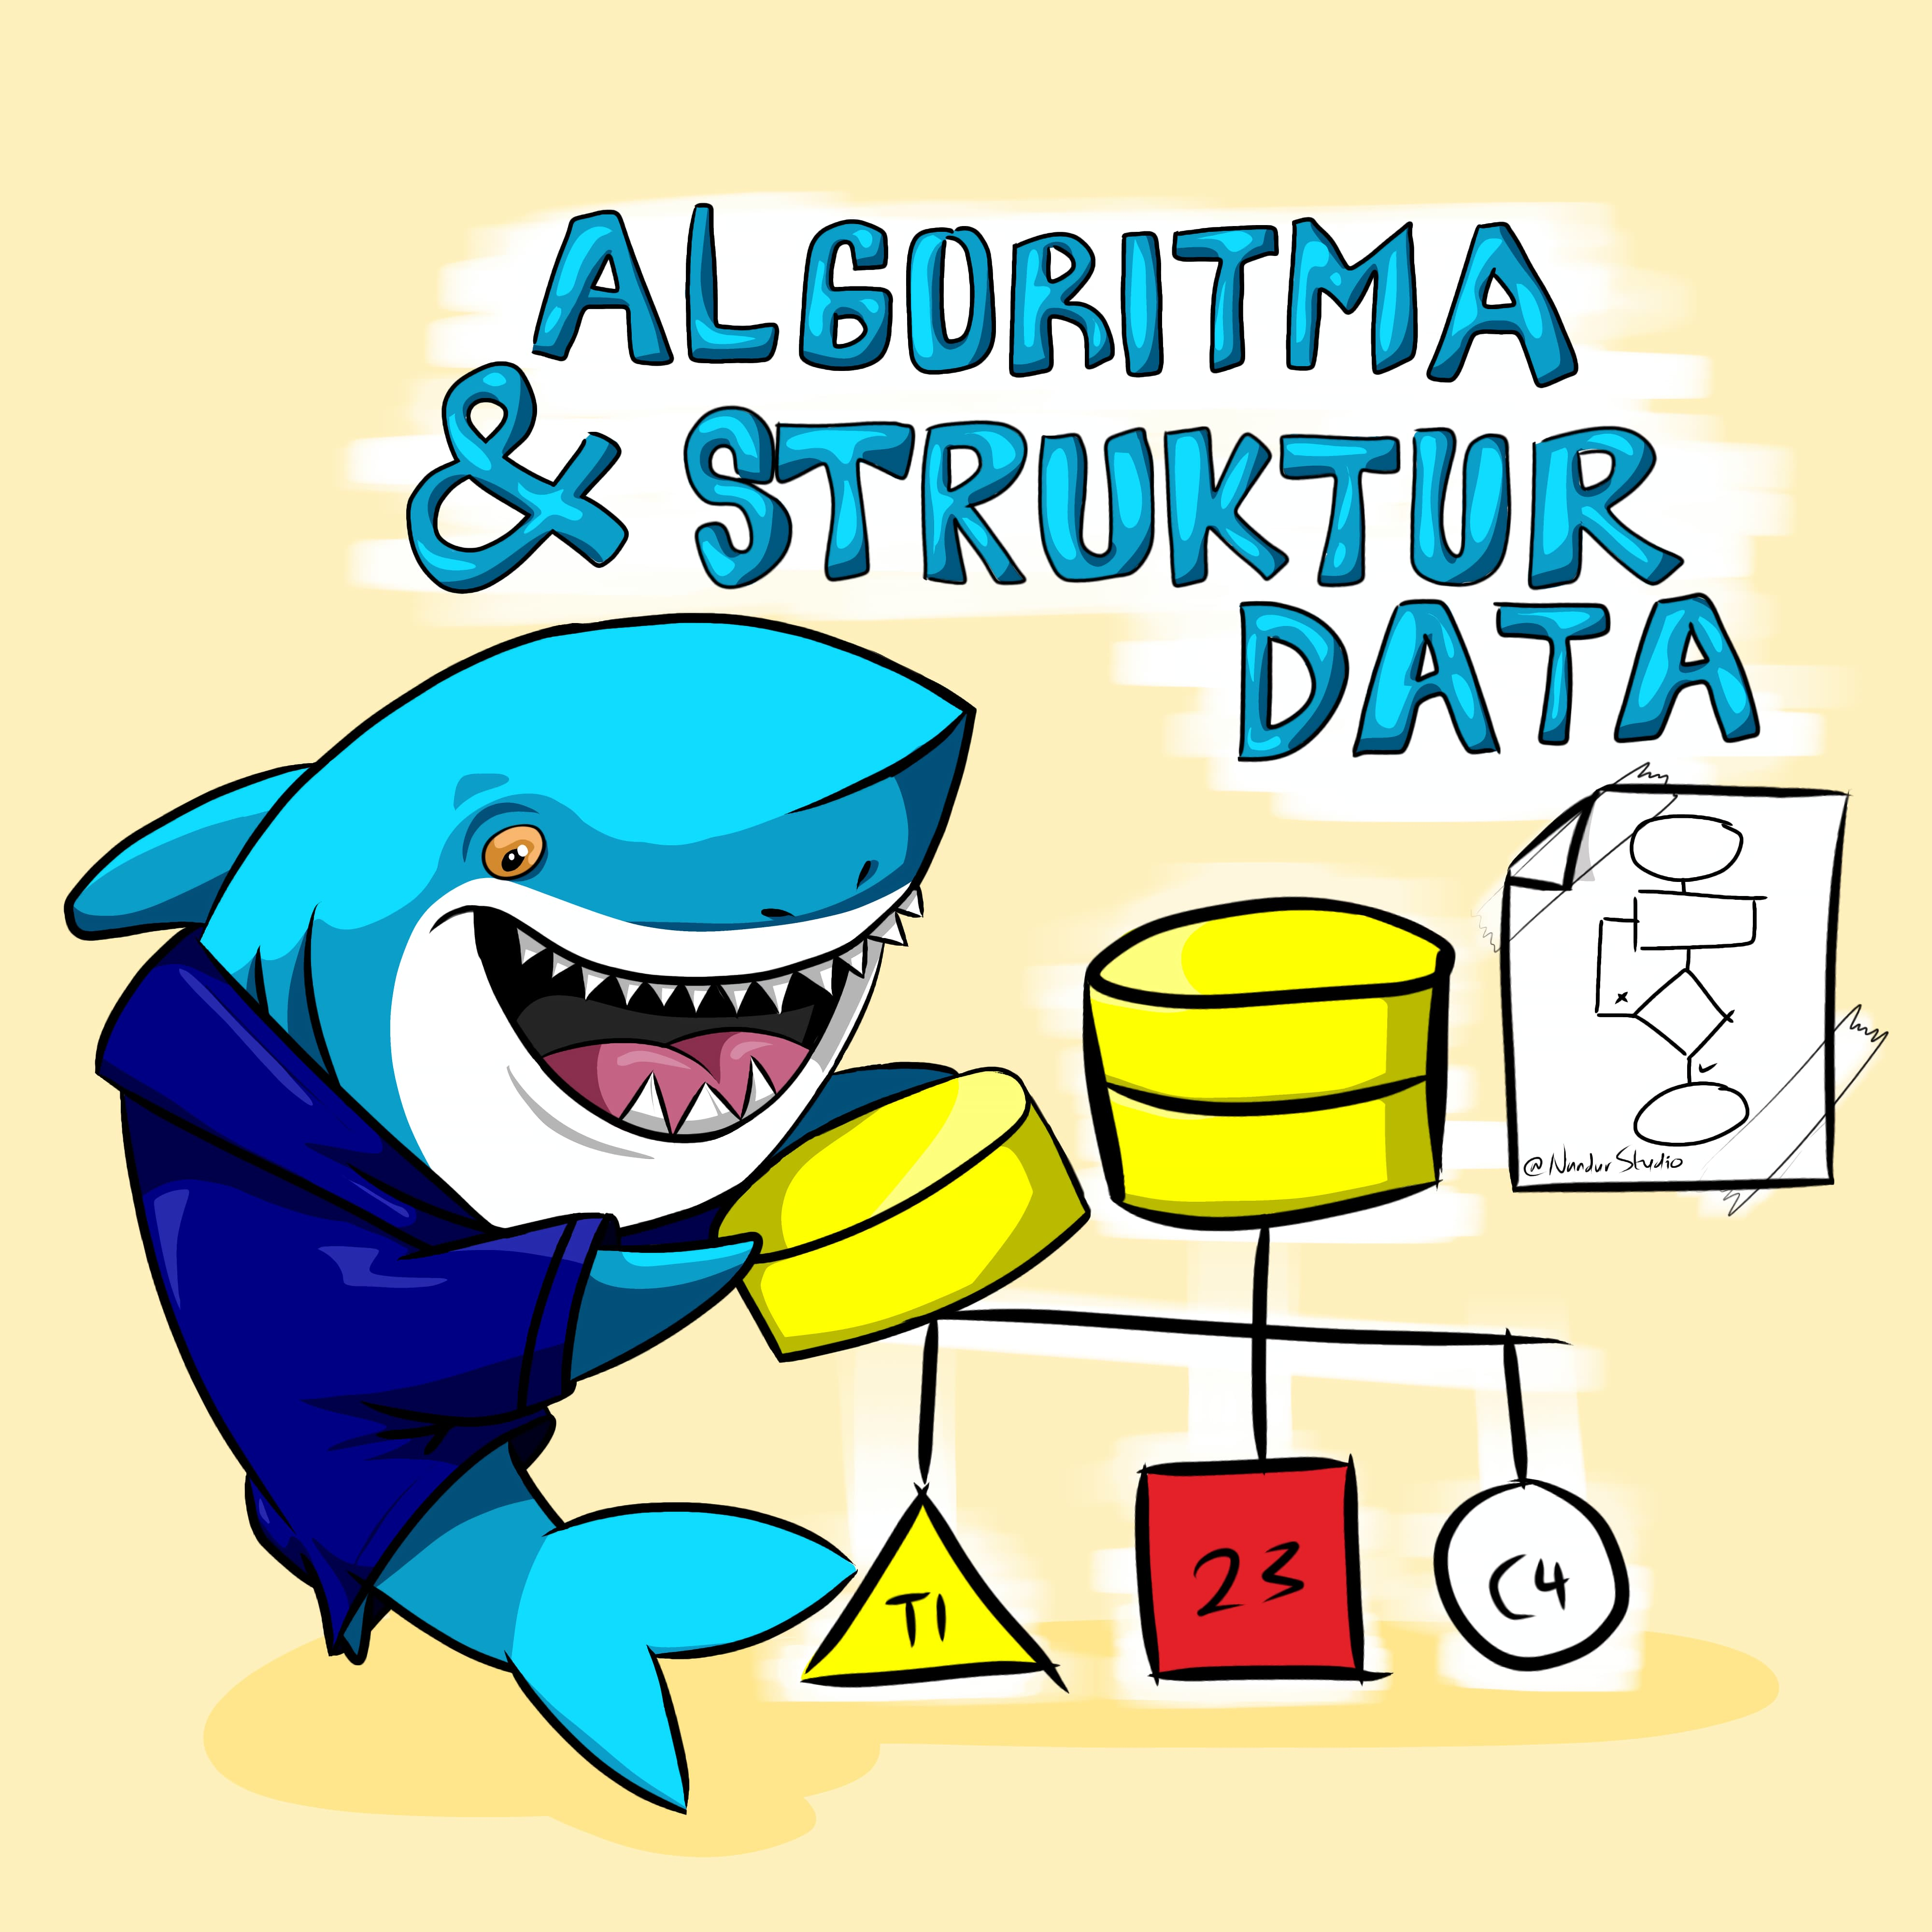

2023

Tugas Algoritma & Struktur Data

Nandang Duryat – 312310233

TI.23.C4

Dosen Muhammad Fatchan, S.Kom., M.Kom., MTCNA.

Sabtu, 04-Nov-23

Pertemuan ke 7

**Tugas – Read & Write File Python**

IDE, Console & Debugger : VSCode

Operating System : Windows 10 pro

**Read & Write File Python**

# Menulis File.

file1 = open("myfile.txt","w")

L = ["This is Delhi \n","This is Paris \n","This is London \n"]

# \n is Ahir kalimat

file1.write("Hello \n")

file1.writelines(L)

file1.close() #to change file access modes

file1 = open("myfile.txt","r+")

print("Output of Read function is ")

print(file1.read())

print()

# Membuka Handle File

file1.seek(0)

print( "Output of Readline function is ")

print(file1.readline())

print()

file1.seek(0)

#menunjukkan perbedaan antara read dan readline

print("Output of Read(9) function is ")

print(file1.read(9))

print()

file1.seek(0)

print("Output of Readline(9) function is ")

print(file1.readline(9))

#menunjukkan perbedaan antara read dan readline

# readlines function

print("Output of Readlines function is ")

print(file1.readlines())

print()

file1.close()

#===================================================================

# Program Python Append

# Append vs write mode

file1 = open("myfile.txt","w")

L = ["This is Delhi \n","This is Paris \n","This is London \n"]

file1.writelines(L)

file1.close()

# Append-adds at last

file1 = open("myfile.txt","a")#append mode

file1.write("Today \n")

file1.close()

file1 = open("myfile.txt","r")

print("Output of Readlines after appending")

print(file1.readlines())

print()

file1.close()

# Write-Overwrites

file1 = open("myfile.txt","w")#write mode

file1.write("Tomorrow \n")

file1.close()

file1 = open("myfile.txt","r")

print("Output of Readlines after writing")

print(file1.readlines())

print()

file1.close()

**Code Python File 1**

1. # Membuka file "myfile_f1.txt" dalam mode 'w' (write)
2. file1 = open("myfile_f1.txt", "w")
3. # Membuat sebuah daftar (list) yang berisi tiga kalimat dengan karakter newline di akhirnya
4. L = ["This is Delhi \n", "This is Paris \n", "This is London \n"]
5. # Menulis string "Hello" ke dalam file, diikuti dengan karakter newline
6. file1.write("Hello \n")
7. # Menulis semua elemen dalam daftar L ke dalam file
8. file1.writelines(L)
9. # Menutup file setelah selesai menulis (untuk mengubah mode akses file)
10. file1.close()
11. # Membuka kembali file "myfile_f1.txt" dalam mode 'r+' (read and write)
12. file1 = open("myfile_f1.txt", "r+")
13. # Membaca dan mencetak seluruh isi file ke layar
14. print("Output of Read function is ")
15. print(file1.read())
16. print()
17. # Menggeser kursor baca ke awal file
18. file1.seek(0)
19. # Membaca dan mencetak satu baris pertama dari file
20. print("Output of Readline function is ")
21. print(file1.readline())
22. print()
23. # Menggeser kursor baca ke awal file
24. file1.seek(0)
25. # Menunjukkan perbedaan antara read dan readline
26. print("Output of Read(9) function is ")
27. print(file1.read(9))
28. print()
29. # Menggeser kursor baca ke awal file
30. file1.seek(0)
31. # Membaca dan mencetak 9 karakter pertama dari file
32. print("Output of Readline(9) function is ")
33. print(file1.readline(9))
34. # Menggeser kursor baca ke awal file
35. file1.seek(0)
36. # Menunjukkan perbedaan antara read dan readline
37. # Menggunakan readlines function untuk membaca dan mencetak seluruh isi file sebagai daftar baris
38. print("Output of Readlines function is ")
39. print(file1.readlines())
40. print()
41. # Menutup file setelah selesai membaca dan menulis
42. file1.close()

**Output Console**

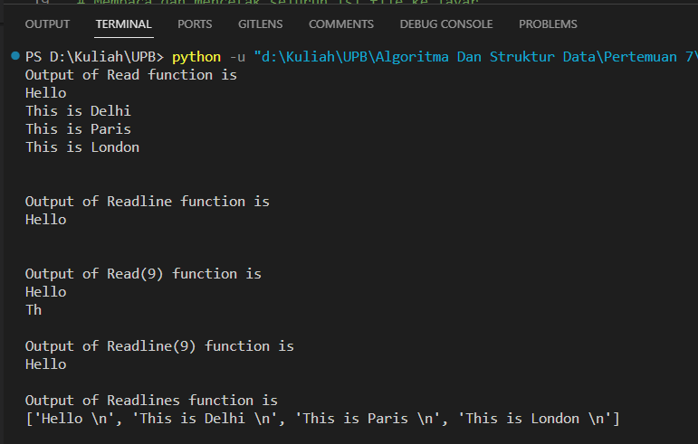

**Output Text File**

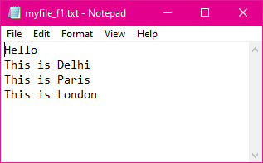

**Code Python File 2**

1. # Program Python Append
2. # Append vs write mode
3. # Nama file yang akan digunakan
4. nama_file = "myfile_f2.txt"
5. # Membuka file dalam mode 'w' (write) dan menulis beberapa baris teks ke dalamnya
6. file1 = open(nama_file, "w")
7. L = ["This is Delhi \n", "This is Paris \n", "This is London \n"]
8. file1.writelines(L)
9. file1.close()
10. # Membuka file dalam mode 'a' (append) dan menambahkan teks di akhir file
11. file1 = open(nama_file, "a")  # mode tambahan
12. file1.write("Today \n")
13. file1.close()
14. # Membuka file dalam mode 'r' (read) dan mencetak seluruh isi file
15. file1 = open(nama_file, "r")
16. print("Output of Readlines after appending")
17. print(file1.readlines())
18. print()
19. file1.close()
20. # Membuka file dalam mode 'w' (write) dan menulis teks baru, menggantikan isi file sebelumnya
21. file1 = open(nama_file, "w")  # mode penulisan
22. file1.write("Tomorrow \n")
23. file1.close()
24. # Membuka file dalam mode 'r' (read) dan mencetak seluruh isi file setelah penulisan
25. file1 = open(nama_file, "r")
26. print("Output of Readlines after writing")
27. print(file1.readlines())
28. print()
29. file1.close()

**Output Console 2**

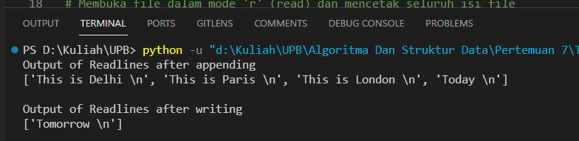

**Output Text File 2**

